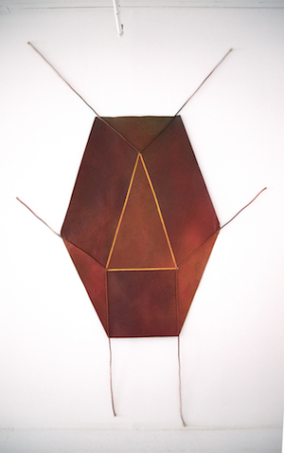[insert image]

Joe Overstreet, Paintings 1970-72
Frieze Masters

Eric Firestone Gallery is pleased to announce its participation in Frieze Masters with the installation: Joe Overstreet, Flight Pattern Paintings 1970-72. The installation will be an opportunity to revisit a radical body of work made nearly 50 years ago. It is the first time they will be shown as a group in Europe.

Many of these pieces have not been seen since a seminal solo exhibition in 1972 in Houston, Texas.
The 1972 exhibition was catalyzed by art patrons Dominique and John de Menil, as part of their efforts to de-segregate the art world, Rice University, and effect social change in troubled Houston neighborhoods. The show traveled within the city of Houston, beginning at Rice University and then moving to the DeLuxe Art Center.

Overstreet’s paintings are un-stretched canvases installed with ropes threaded through grommets and attached to the ceiling, wall, and floor. The language of geometric abstract painting is re-imagined into monumental installations that tell stories about the painful realities of African American history, and also read as symbols of hope, flight, and aspiration. In particular, the Frieze Masters installation will focus on shaped canvases that suggest talismans, flags, or shields, with short lengths of rope that attach to the wall.

Overstreet was born in 1933 in rural Mississippi. Like many African American families who were part of the Great Migration, Overstreet’s early life was nomadic, and his early exposure was to Black and Native American rural culture. In the 1950s, Overstreet studied at the California School of Fine Arts (San Francisco) and California College of Arts and Crafts (Oakland). He began his career in the Bay Area, and was a fixture of the Beat scene.

By the mid-1960s, Overstreet began breaking away from the rectangle of the stretcher and from the narrative of Western art history. He used wooden dowels and hand tools to make intricate stretchers, painting in patterns drawn from Aztec, Benin, and Egyptian cultures. After seeing, at the studio of John Chamberlain, a horrifying photograph of four Black men being lynched, surrounded by celebrating white men and women, Overstreet began to make paintings referencing lynching, like Strange Fruit (1965), which included images of ropes.

The “Flight Pattern” paintings resound with these ideas. They also symbolize nomadic structures. Overstreet stated, “I began to make paintings that were tent-like. I was making nomadic art, and I could roll it up and travel… I felt like a nomad myself, with all the insensitivity in America.” Overstreet was interested in maintaining the most appealing feature of nomadic structures: “their tendency, like birds in flight, to take off, to lift up, rather than be held down.”

Overstreet’s work was also central in watershed museum exhibitions of African American artists in the period, including “Afro-American Artists: New York and Boston,” (1973) organized jointly by the Boston Museum of Fine Arts and the National Center of Afro American Artists; and “New Black Artists,” (1970) organized by the Brooklyn Museum. Overstreet was the subject of museum exhibitions at the Everson Museum of Art, Syracuse, NY (1996), and the New Jersey State Museum, Trenton, NJ (1996).

A “Flight Pattern” painting is part of the current exhibition “Soul of a Nation: Art in the Age of Black Power” organized by the Tate Modern, London; and on view at the Brooklyn Museum in the Fall of 2018. “Power Flight” is also in the collection of the Brooklyn Museum. Also in the Fall of 2018, the Menil Collection re-opens with an installation featuring two of Overstreet’s Flight Pattern Paintings. The four-panel shaped canvas construction, “Justice, Faith, Hope, and Peace,” painted in 1968 after the assassination of Martin Luther King, is currently on view at the Mississippi Museum of Art where Overstreet was a recipient of the Governor’s Arts Award in February 2018.

Overstreet has been committed to social and political causes, rather than art world trends. He is recognized as a significant arts community organizer. In 1973, he and his partner Corrine Jennings established Kenkeleba House on East 2nd Street, a studio building and gallery that has presented innumerable exhibitions of work by artists of color and women.

Over the past several decades, Overstreet has been a relentless experimenter – investigating both the spatial and textural possibilities of painting, and also complex cultural histories. In revisiting this pioneering body of work by Overstreet, we begin to recognize the impact of his contribution and extent of his innovation.

